NMM-112
DAY 2 TAKE HOME QUIZ

- Which action code does not indicate a delay in measurement reported by the

facility receiving nuclear material.
  - J
  - U
  - N
- On which form(s) does a facility report material to the assay specific material

types, such as E2 and 35?
  - DOE/NRC Form 741
  - DOE/NRC Form 742
  - DOE/NRC Form 742C
  - A and C
  - B and C
- Which action code(s) can be reported on a receiver DOE/NRC Form 741?

  - D
  - A
  - P
  - C
  - A and C
- Which NRC requirements dictate whether a facility submits a material status

report to NMMSS?
  - inventory of 1 gram or more of special nuclear material
  - inventory of 1 kilogram or more of source material (not foreign obligated)
  - licensee that in any manner transfers, receives, or adjusts the inventory of
source material of foreign obligations by 1 kilogram or more
  - A and C
  - A, B, and C
- The following inventory material type code does not represent high

enriched uranium.
  - 39
  - E2
  - 34
  - E3
- The unit of measurement for reporting total gross weight and total volume

are to the nearest whole kilogram and cubic meter (DOE) or feet (NRC), respectfully.
  - TRUE
  - FALSE
- What is the collective term used for the change identifier and the subsequent line

numbers entered to identify detail lines to be corrected on the DOE/NRC Form 741?
  - TI code, for account, and to account
  - correction number
  - back reference
  - B and C

- What field is not negated on a DOE/NRC Form 741 correction line that is backing

out a previously submitted detail line?
  - element weight
  - weight percent isotope
  - isotope weight
  - number of items
- Sites with reportable quantities of nuclear material must reconcile with NMMSS

every two years.
  - TRUE
  - FALSE
- There is a limit of three foreign obligation countries that can be layered when

reporting foreign obligations to NMMSS.
  - TRUE
  - FALSE
- XCEL Energy (RIS XTT) is ready to prepare their Material Balance Forms for the period: 10/1/2020 through 9/30/2021. This facility has reportable non-DOE-owned enriched uranium and plutonium.
ENRICHED URANIUM:
- The beginning balance for enriched uranium is 1,000 grams with an isotope weight of 600 grams.
- During the year, the facility received 50 grams element weight (20 grams isotope weight) of material from facility BAX.
- Production activities have increased the material balance by 20 grams element (10 grams isotope weight).
- There were 2 shipments during the year. One shipment went to YBX with an element weight of 60 and an isotope weight of 30. The second shipment went to facility ZCZ with and element weight of 100 and an isotope weight of 40.
- 500 grams element and 290 grams isotope of material type 20 is obligated to Euratom as of the end of the reporting period (obligation code: 87).
PLUTONIUM:
- The beginning balance for Material type 50 is 200 grams element weight with an isotope weight of 120 grams.
- XCEL Energy has decay to report in the amount of 10 element weight and 5 isotope weight.
- There was no other activity on the MT 50 throughout the year.
Populate the DOE/NRC Form 742 for XCEL Energy (XTT) for enriched uranium and plutonium.

Problem 11: ENRICHED URANIUM
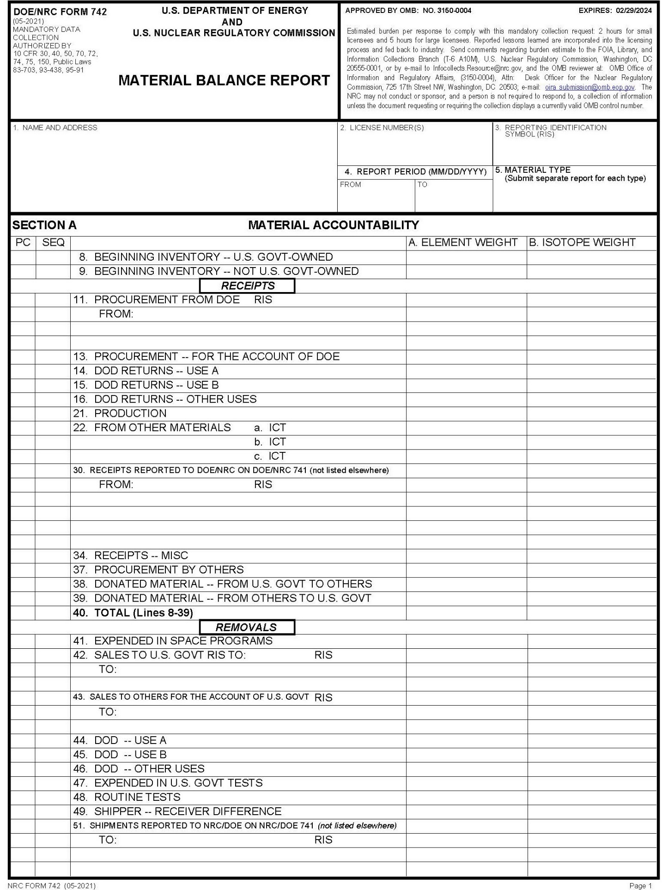

5. MATERIAL TYPE (submit separate report for each type)

FROM
TO
4. REPORT PERIOD (MM/DD/YYYY)

3. REPORTING IDENTIFICATION SYMBOL (RIS)
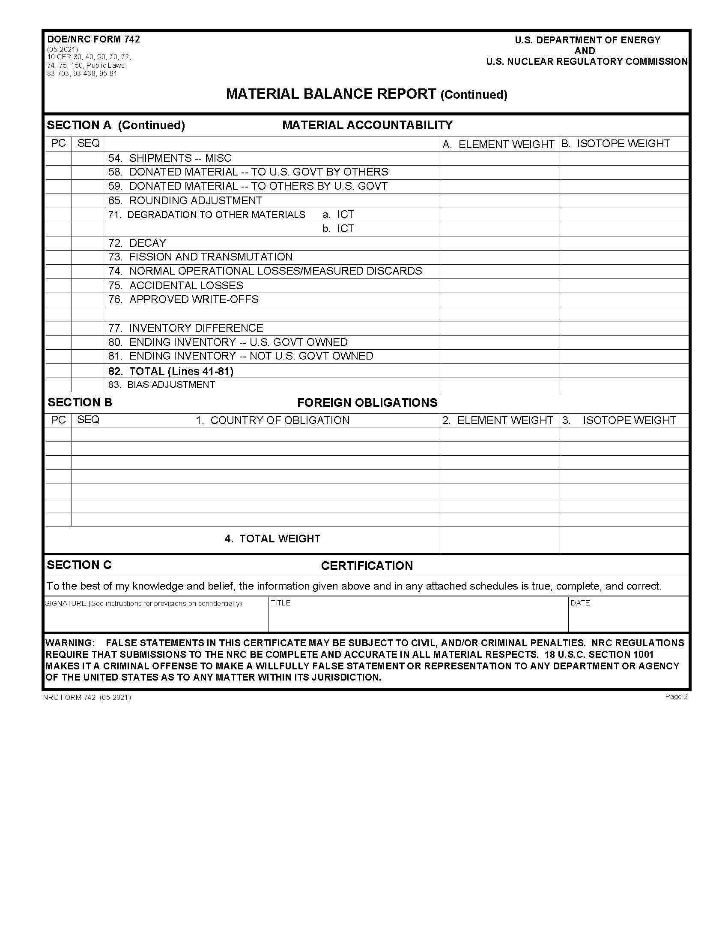

Problem 11: PLUTONIUM

5. MATERIAL TYPE (submit separate report for each type)

TO
FROM

4. REPORT PERIOD (MM/DD/YYYY)

3. REPORTING IDENTIFICATION SYMBOL (RIS)

- Eternal Energy Enterprise (EEE) is preparing their composition of ending inventory used in fuel separation for June 10, 2022.
- This facility has 144 grams element and 16 grams isotope of DOE-owned material under composition of unirradiated scrap solutions (728) for the project general salvage (GGE099900S). The material is enriched uranium (MT33).
- Eternal Energy (EEE) has one gram element and one gram isotope of enriched uranium in the project basic research (GAF909000D). The material has an enrichment of 95.0000% and is DOE-owned. Currently, it is under composition of samples and standards (771).
- This facility has 240 grams element and 170 grams isotope of plutonium that is non-DOE-owned. Currently, it is under composition of material not in process (864).
Populate the DOE/NRC Form 742C for Eternal Energy Enterprise (EEE) for enriched uranium and plutonium.
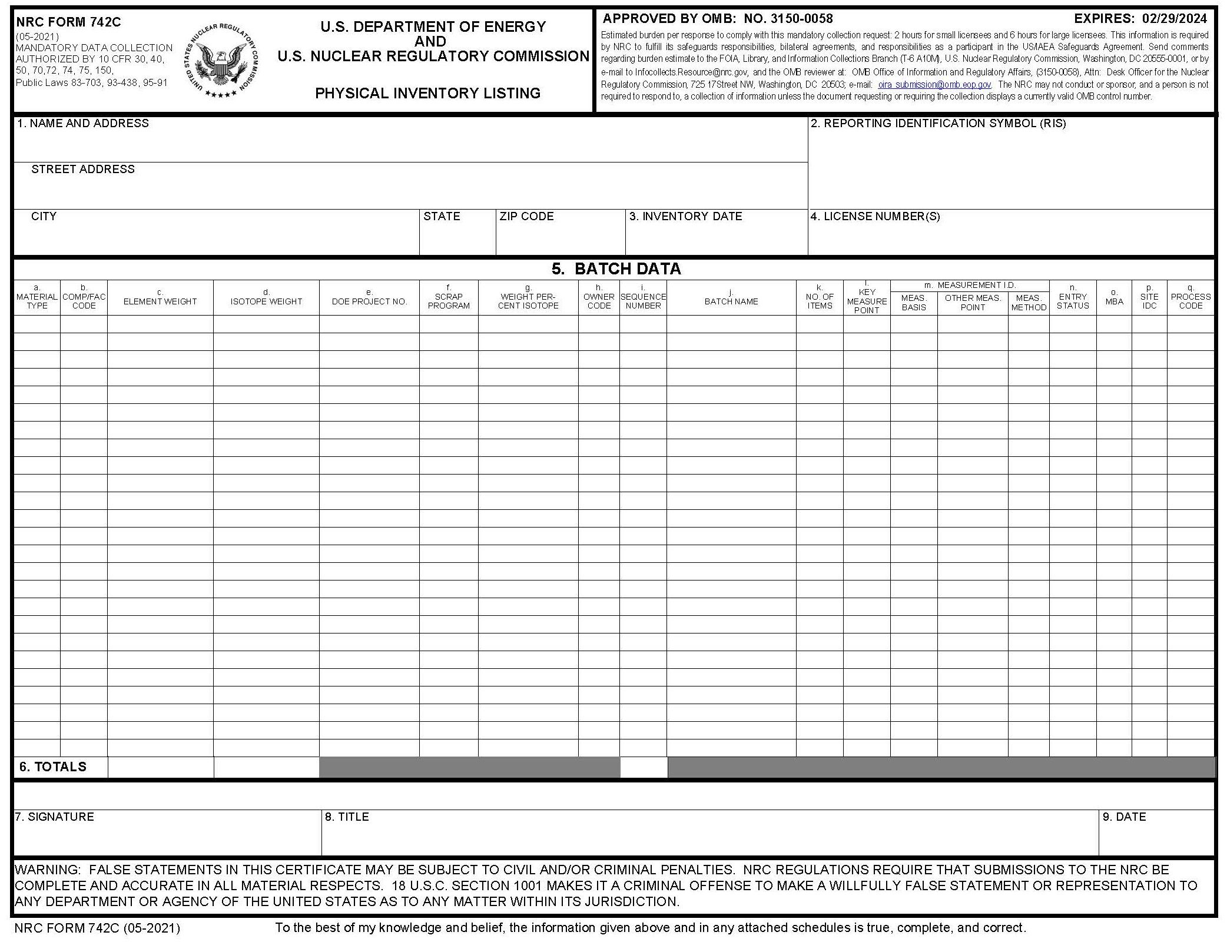

5i..SEQUENCE NUMBER

5h..OWNER CODE
5e..DOE PROJECT NO.

5d..ISOTOPE WEIGHT

5c..ELEMENT WEIGHT
45a.MATERIAL TYPE

5b.COMP/ FAC CODE

3. INVENTORY DATE

2. REPORTING IDENTIFICATION SYMBOL (RIS)

- NRC facility (XDD) made its shipment #1 to a Canadian facility (RDAD) on May 30, 2020. The shipment has non-DOE-owned material being transferred to RDAD. There is one container (Batch 1) of material being shipped which contains 2 types of reportable nuclear material (i.e., 2 lines of detail on the DOE/NRC Form 741). Note that XDD also wants to associate a concise note with this shipment. Populate the shipper’s DOE/NRC Form 741.

Shipping Weight: 20,000 grams
Export License: XPPT5000
Line 1 Line 2
Element Weight: 2000 grams Element Weight: 20 grams
Weight % Isotope: 1.5 Weight % Isotope: 39.0000
Isotope Weight: 30 grams Isotope Weight: 10 grams
Material Type: Enriched Uranium Material Type: Plutonium
Comp Code: 271 Comp Code: 271
Number of Items: 1 Number of Items: 1
Batch ID: Batch A Batch ID: Batch 1

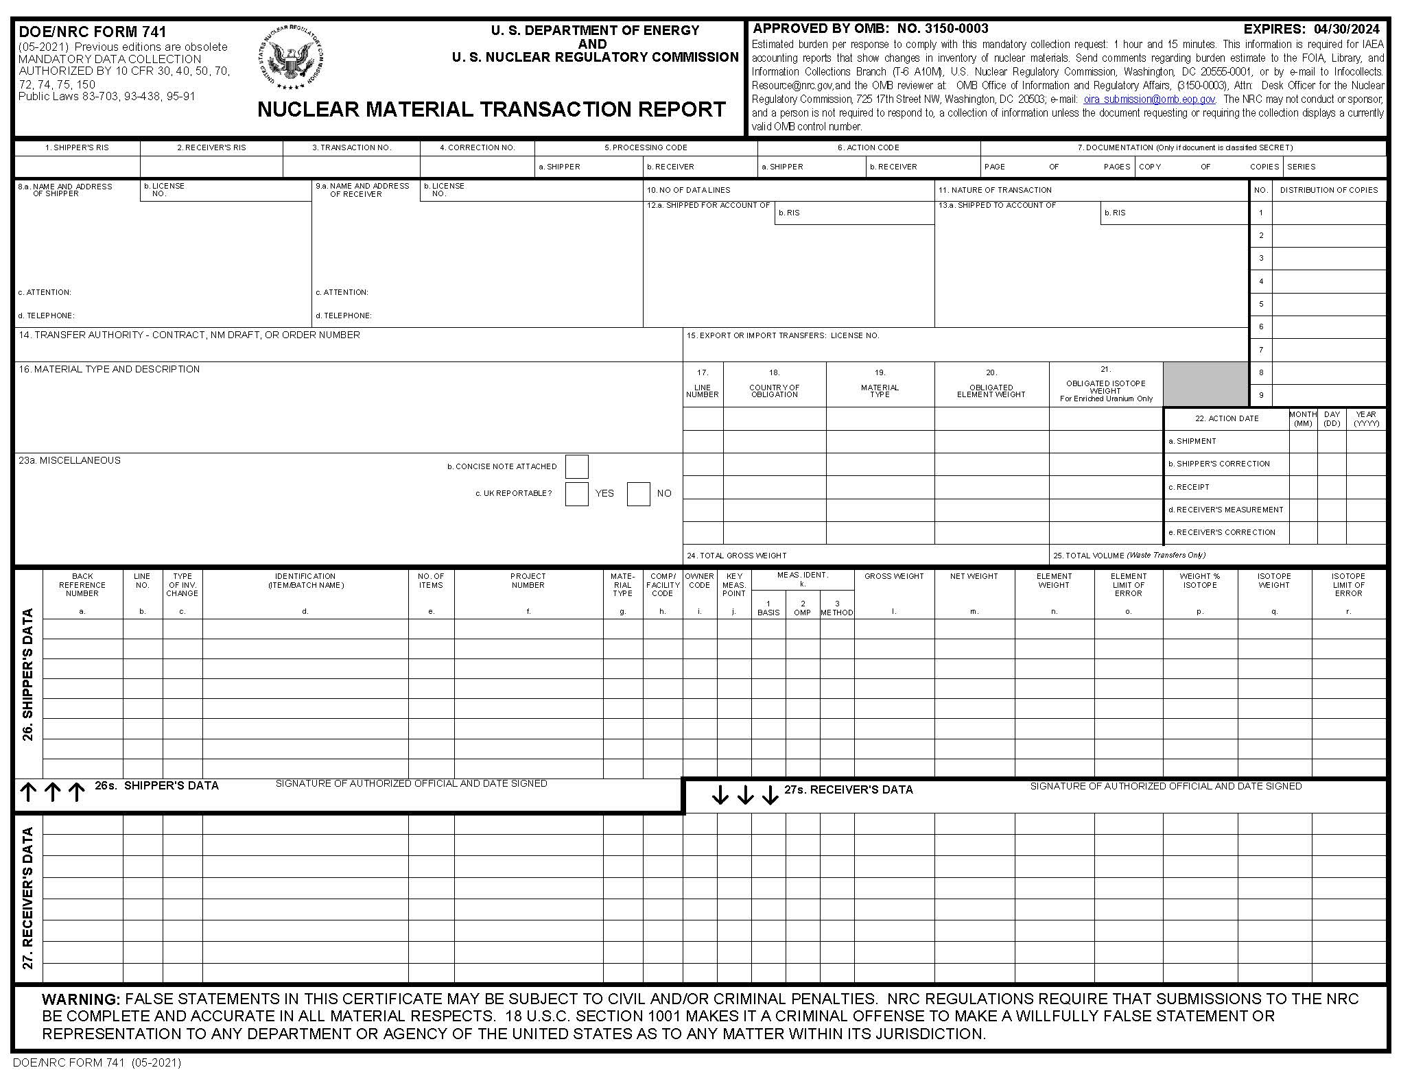

26i.OWNER CODE

26n.ELEMENT WEIGHT

26p.WEIGHT % ISOTOPE
26q.ISOTOPE WEIGHT

26h.COMP/ FACILITY CODE

26g.MATERIAL TYPE

26e.NO. OF ITEMS

27d.BATCH NUMBER

26b.LINE NO.

15.EXPORT OF IMPORT LICENSE NO.

10.NO. OF DATA LINES
23b.CONCISE NOTE ATTACHED

2.RECEIVER RIS
3.TRANSACTION NUMBER

24.TOTAL GROSS WEIGHT

22.ACTION DATE
6.ACTION CODE

5.PROCESSING CODE

1.SHIPPER RIS
- Since XDD indicated the intent to include a concise note with this shipment, enter the shipper’s DOE/NRC Form 740M (concise note). Note that this concise note is applicable to the whole report (i.e., all lines of the associated DOE/NRC Form 741).
Concise Note:
Line 1: The submission is safeguards
Line 2: information and should be handled
Line 3: in accordance with 10 CFR 73.21,
Line 4: Protection of Safeguards Information
Line 5: Performance Requirements

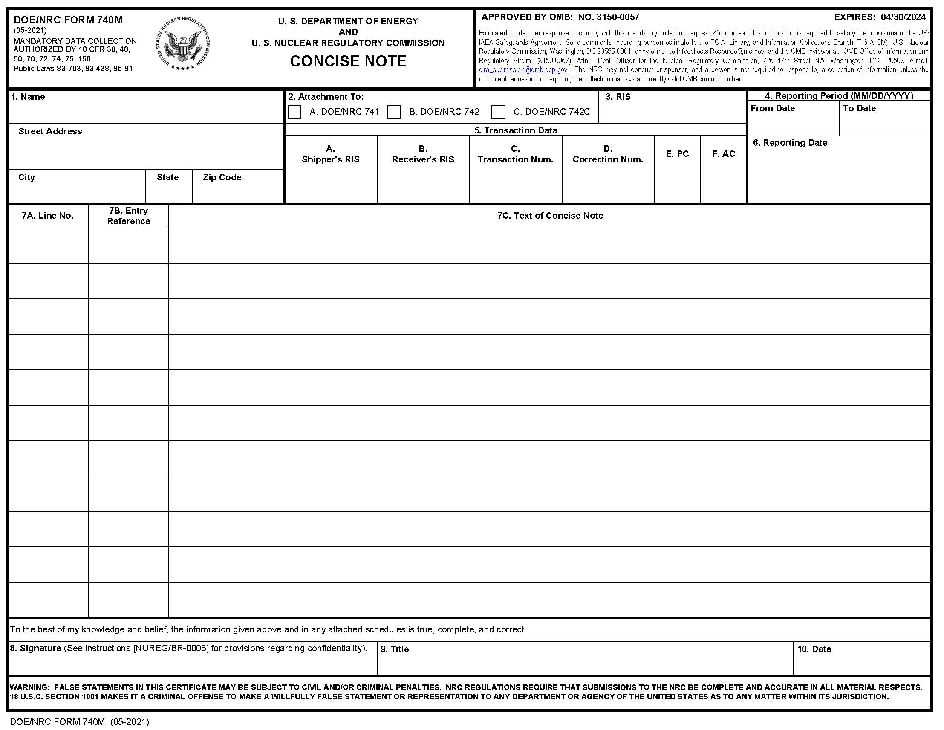

7C. TEXT OF CONCISE NOTE

7B. ENTRY REFERENCE

7A. LINE NO

- DOE/NRC 741

2.ATTACHMENT TO

6. REPORTING DATE

5B. RECEIVER’S RIS

5C. TRANSACTION NUM.

5E. PC

5F. AC
5A. SHIPPER’S RIS

